**[HTML's Are Easy!](https://labs.hacktify.in/HTML/html_lab/lab_1/index.php" \o ")**

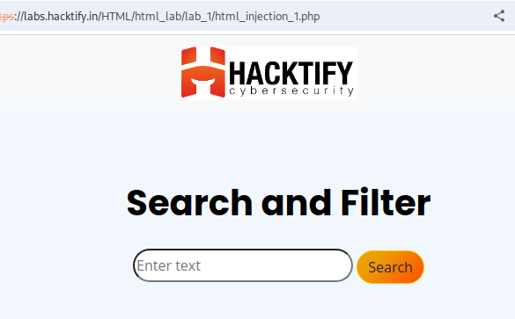

Will try to search with <h1>Hacked</h1>

On the Intercept in BurpSuite and forward the request.

You will “Hacked” as header in your website.

This concludes that we can inject HTML tags in website too to create malicious payloader.